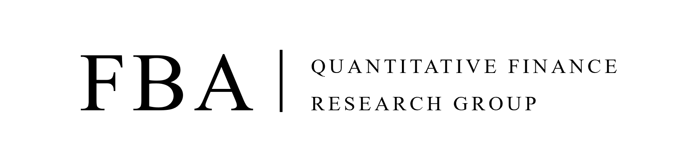
FBA Quant 2023 Winter Recruitment Application Form
(Deadline: 11:00 PM, Jan 21st, 2023)

PERSONAL DETAILS
Photo | Name
 | Date of Birth
 | Address
 | E-mail Address
 | Mobile

EDUCATION
Year of Admission  - Year of Graduation | University | Major | Degree

CERTIFICATES
Name of Certificates | Issuing Organization | Year of Acquisition

AWARDS AND ACHIEVEMENTS
Name of Competition | Organization / Sponsorship | Award

WORK EXPERIENCES
Company | Department | Position | Year of Employment

OTHERS
Please list courses you have taken that are relevant to mathematics, computer science, statistics, and finance for Relevant Courses (Please specify the year you have taken)
Language proficiency
(Spoken/Written)
Programming Languages
Other Activities
Relevant Courses | Finance:  Economics:  Mathematics:  Statistics:  Programming:

ESSAY
Q. What is Your Career Goal?
Q. Why FBA Quant?
Q. Why You?

FBA QUANT VIDEO INTERVIEW TIMESLOT
Please mark ‘v’ on the slots that you will be available for the interview
(please select as many slots as possible as the time slot fills up quickly)
Video Interview Time Slot
Jan 22nd, 2023 |  | Jan 23rd, 2023
09:00 ~ 10:00 |  | 09:00 ~ 10:00
10:30 ~ 11:30 |  | 10:30 ~ 11:30
13:00 – 14:00 |  | 13:00 – 14:00
14:30 – 15:30 |  | 14:30 – 15:30
16:00 – 17:00 |  | 16:00 – 17:00
20:00 – 21:00 |  | 20:00 – 21:00
21:30 – 22:30 |  | 21:30 – 22:30

Jan 24th, 2023 |  | Jan 25th, 2023
09:00 ~ 10:00 |  | 09:00 ~ 10:00
10:30 ~ 11:30 |  | 10:30 ~ 11:30
13:00 – 14:00 |  | 13:00 – 14:00
14:30 – 15:30 |  | 14:30 – 15:30
16:00 – 17:00 |  | 16:00 – 17:00
20:00 – 21:00 |  | 20:00 – 21:00
21:30 – 22:30 |  | 21:30 – 22:30

FBA QUANT TRACK PREFERENCE
Please write down your preference ranking (1st ~ 3th)
This will be actively considered when organizing FBA Quant track
FBA Quant Track
Quant Strat
- Interest-Rate Derivatives
- Volatility Derivatives
Asset Management
- Factor Models
- Portfolio Management
Quant Trading
- Market Microstructure
- Market Making

